**General Email Template** 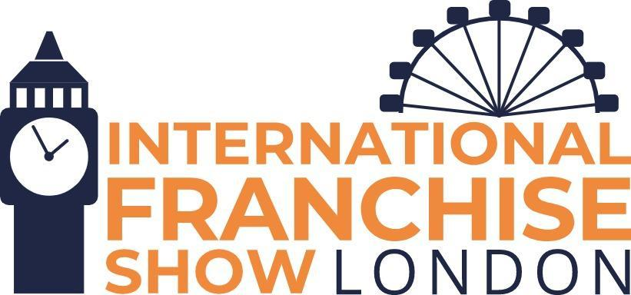

Hi XXXX,

We’re exhibiting at this year’s International Franchise Show on the 8th and 9th of April at ExCeL, London! Come and meet us on stand XXX and find out about our unique franchise opportunity.

If you haven’t yet registered for a ticket at the event, you can grab your ticket here: [www.thefranchiseshow.co.uk/?utm_campaign=exhibitor-marketing](https://www.thefranchiseshow.co.uk/?utm_campaign=exhibitor-marketing)

Your **FREE** ticket gives you access to over 250 franchise opportunities, 60+ insightful seminars and interactive panel debates and workshops.

We look forward to seeing you shortly!

Thanks,

XXXXX